BLESSED ROLLAND S23B13/066 B24402

Restaurant Management System

Use Cases and Actors

Actors:

Customer: Places orders, makes payments, receives food, views order history, receives notifications.

System Admin: Manages users, restaurants, menus, and overall system settings.

Hotel Admin: Manages their restaurant's menu, orders, and staff.

Use Cases:

Register: Customer creates an account with the system.

Login: Customer logs in to access the system.

Search Hotel Food: Customer searches for restaurants and specific food items.

Add Item to Order: Customer selects items from the menu and adds them to their order.

View Order Bill: Customer reviews the order details and total bill amount.

Pay Order: Customer chooses a payment method and completes the transaction.

Update Menu: Hotel Admin adds, edits, or removes items from their restaurant's menu.

Sales: System Admin and Hotel Admin view sales reports and analyze data.

Cancel Order: Customer cancels an order before it's processed by the restaurant.

Track Order: Customer tracks the status of their order in real-time.

Receive Notifications: Customer receives notifications about order updates, promotions, and other relevant information.

History of Orders: Customer views their past order history.

Add/Remove Hotels: System Admin adds or removes restaurants from the platform.

Sequence Diagram

Register:

1. Customer enters registration information (name, email, password).

2. System validates the information and creates a new user account.

3. System sends a confirmation email to the customer.

Place Order:

1. Customer selects a restaurant and browses the menu.

2. Customer adds items to their order and specifies any modifications.

3. Customer reviews the order details and confirms it.

4. System sends the order to the restaurant.

5. Restaurant receives the order and starts preparing the food.

6. Restaurant updates the order status (e.g., "Preparing," "Ready").

7. Customer receives notifications about the order status updates.

8. Restaurant delivers the food to the customer.

Pay Order:

1. Customer chooses a payment method (e.g., credit card, debit card, online wallet).

2. System processes the payment and sends a confirmation to the customer.

3. Restaurant receives confirmation of the payment.

RESTAURANT MANAGEMENT SYSTEM USE CASE DIAGRAM

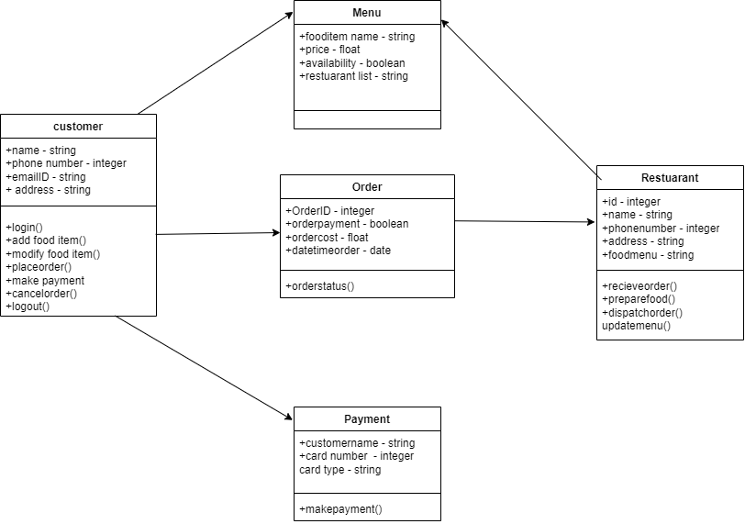

BLESSED ROLLAND S23B13/066 B24402

RESTAURANT MANAGEMENT SYSTEM USE CASE DIAGRAM

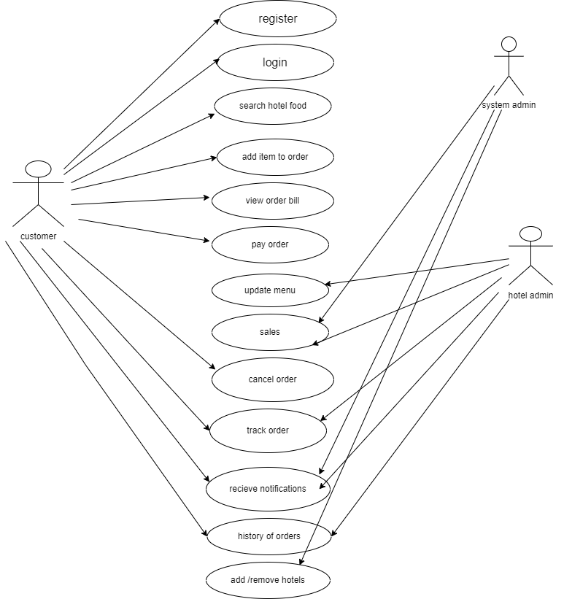

RESTAURANT MANAGEMENT SYSTEM SEQUENCE DIAGRAM

